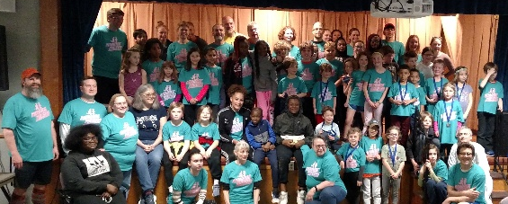

Monroe Milers

A Running Program for Boys and Girls
September and October 2019

Walk to Run
Monroe Milers is a high quality, developmentally appropriate youth running program. Over 8 weeks, kids will train for a 5K or one-mile race. They will walk/run in groups of six or seven with two to three coaches. Running games are a regular part of practice.

Who can participate?
Youth, ages 8 and up, train for a 5K race. There is a group for walkers. A young runners group, ages 6 and 7, trains for a one-mile race.
Adults interested in volunteering as a coach or support staff should contact Nancy at allinbas@outlook.com.

When and Where
Monroe Milers meets for about an hour every Wednesday at 6 p.m. and every Sunday at noon, starting September 4, 2019. Training runs start at St. John’s Home, on the corner of South and Highland Avenues. The program will culminate with the Pumpkins in the Park race on October 26, 2019.

What’s in it for you?
In addition to the satisfaction of improving physical fitness, making new friends, and setting and achieving a goal, participants

-receive one pair of running shoes per year.
-receive one T-shirt per year.
-earn attendance awards.
-earn free entry into the 5K race.
-have healthy snacks post workout.

What is expected from you?
Participants are asked to sign an attendance contract, agreeing to miss no more than three practices. To ensure a safe and enjoyable experience, they are expected to abide by program rules and listen to their coaches’ directions. They are expected to come with a positive attitude, to work as a team and to have fun.

Registration fee: $15 per child (Scholarships available-contact Nancy at allinbas@outlook.com)
Enrollment is limited to 50 youth. Registration is on a first come first served basis. Make checks out to South Presbyterian Church and return with registration to South Presbyterian Church, 144 Metro Park, Suite 3C, Rochester, NY 14623. Monroe Milers is sponsored by South Presbyterian Church.
Monroe Milers is made possible through the support of friends of the Monroe Milers and
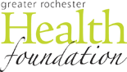
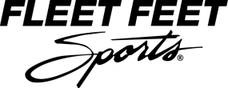

MONROE MILERS REGISTRATION & PERMISSION FORM
My child has permission to participate in the Monroe Milers Club (South Presbyterian Church) at St. John’s Home. I understand the program will take place Wednesdays at 6 p.m. and Sundays at noon for 8 weeks beginning September 4, 2019. My child also has permission to participate in Pumpkins in the Park 5K on October 26, 2019.

CHILD’S NAME: ____________________________________________

ADDRESS: _________________________________________________
___________________________________________________________
EMAIL:____________________________________
PHONE #: __________________________________
EMERGENCY CONTACT: ___________________
PHONE #: ______________________

BIRTHDAY: DD/MM/YYYY________________
GENDER Male Female
SHIRT SIZE: Adult S M L or Youth S M L
SHOE SIZE: Adult _________ or Child/Kid’s ___________
RUNNING GOAL: ______________________________________________________________
ALLERGIES OR PHYSICAL/HEALTH CONDITIONS: ________________________________
_______________________________________________________________________________

WAIVER
I give permission for my child to participate in the Monroe Milers and Pumpkins in the Park 5K run. I give permission for volunteers to administer first aid treatment and/or allow a physician or hospital to administer treatment to my child in case of emergency. I waive and release any and all rights, claims, and causes of action I have or may have against South Presbyterian Church, Fleet Feet Sports/Yellow Jacket Racing, and Greater Rochester Health Association that may arise as result of my child’s participation in the Monroe Milers and the 5K run. I allow the Milers to use photographs of my child for official program use without compensation.

PARENT SIGNATURE: __________________________
DATE: _____________________________
Office Use Only:
Registration fee paid
Cash _______ Check _______

